**Lab Report**

Title: Lab 3: Deliveries

Notice: Dr. Bryan Runck

Author: Cole Anderson

Date: 4/1/21

**Project Repository:**<https://github.com/and04671/GIS5572/tree/main/Lab3>

**Abstract**

The goal of this lab was to create network datasets and use a vehicle routing problem to compare them to pre-made network datasets. Specifically, the routing problem was to find the fastest route for two UPS trucks to deliver 10 packages on time, not drive on 35W and 94, and then return home. In order to create the necessary network dataset, a base street centerlines layer was required, in addition to a set of parameters regarding costs and units of time/distance. The other network was a pre-made ESRI file. The given addresses were then geocoded in ArcPro. Barrier polygons were required to prevent travel on restricted interstates, with intersections removed to still allow crossing. Once these items were completed, they were fed to a VRP (Vehicle Routing Problem) as orders, depots, and barriers. Route criteria were created next in order to specify the costs and number of routes. The VRP layer was then solved to create the most effective routes, displaying them to a map and printing directions. This entire process was repeated on each network dataset, and the total times compared. Both seemed to have about a minimum time of 2:20-2:45, and satisfied the evaluation criteria.

**Problem Statement**

2 delivery drivers starting from 1436 Lone Oak Rd, St Paul, MN 55121 at 8:00 AM must deliver 10 packages to 10 listed addresses and return to the start point in the shortest time possible. Find the best (fastest) routes between the 2 drivers, avoiding both 94 and 35W. Solve the problem in ArcGIS Pro and ArcGIS Online using your own constructed network dataset. (Can compare with ESRI’s proprietary network services). **Modified: compare new and ESRI network datasets in ArcPro.**

Deliveries:

5525 Cedar Lake Rd S, St Louis Park, MN 55416

225 Thomas Ave N #700, Minneapolis, MN 55405  MUST arrive between 10 and 11am

701 N 5th St, Minneapolis, MN 55401

920 E Lake St #123, Minneapolis, MN 55407

783 Harding St NE, Minneapolis, MN 55413

4165 W Broadway Ave, Robbinsdale, MN 55422

1321 E 78th St, Bloomington, MN 55425

12547 Riverdale Blvd, Coon Rapids, MN 55448

9875 Hospital Dr, Maple Grove, MN 55369

3300 Oakdale Ave N, Robbinsdale, MN 55422 MUST arrive between 10 and 11am

Table 1. Problem Statement Requirements

|  |  |  |  |  |  |  |
| --- | --- | --- | --- | --- | --- | --- |
| **#** | **Requirement** | **Defined As** | **Spatial Data** | **Attribute Data** | **Dataset** | **Preparation** |
| 1 | Street Network | Road centerlines for Twin Cities | Road segment length | Speed Limits | <https://gisdata.mn.gov/dataset/us-mn-state-metrogis-trans-road-centerlines-gac> | Create Network Layer |
| 2 | Delivery Locations | The 10 specified addresses | Point Location | Start/Stop Bounds | Created CSV | Geocode Addresses CSV |
| 3 | Start Locations | Point where routes start | Point Location | Start/Stop Bounds | Created CSV | Geocode Depots CSV |
| 4 | Restrictions | Cannot cross 35W or I94 | Buffer Polygons | n/a | Road centerlines | Select Out |
| 5 | VRP Layer | Layer to solve routing | Delivery, Depots, Routes | Directions | n/a | Above Preps |

**Input Data**

The problem needs data for two different networks, a created one and an ESRI one. A raw road-lines file is required to create the new dataset. We also need the location data given in the brief.

Table 2. Input Data

|  |  |  |  |
| --- | --- | --- | --- |
| **#** | **Title** | **Purpose in Analysis** | **Link to Source** |
| 1 | Road Centerlines | Network Creation | <https://gisdata.mn.gov/dataset/us-mn-state-metrogis-trans-road-centerlines-gac> |
| 2 | ESRI Network DS | Network Comparison | In ArcPro, set source to arcgis.com |
| 3 | Point Locations | Places to visit on routes | Given |

**Methods**

**Create a new Network Dataset:**

Add the RoadCenterlines shapefile to the map and gdb.

Create an ND dataset from the shapefile using Create Network Dataset tool.

In tool, select the shapefile as the Target Feature.

Click Run

A new dataset called MSP_ND will be created.

**Network Dataset Properties:**

To set the correct properties for the network dataset, find it in the .gdb and right click. Click Properties to open a dialog box.

Click the Travel Attributes tab on the side. A set of tabs will appear.

Figure 1: Tab Layout in Network Properties

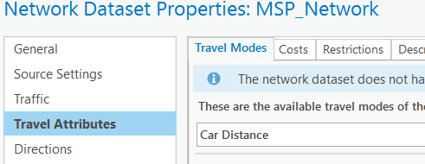

Under Travel Modes: create 2 travel modes called Car Distance and Car Time. Set the impedence as length/meters and time/minutes respectively.

Under Costs: create a new cost called Minutes. Keep units in minutes.

Under evaluators (inside box for selected cost): set type to Field Script. For a script, type [SHAPE_Leng]/([SPEED_IMP]*26.8224) to get an accurate meters per minutes. Do this for Roadlines(Along) and Roadlines(Against).

Figure 2: Evaluators box for Time Cost

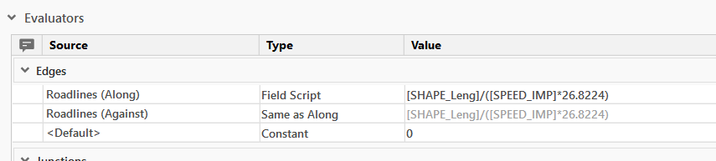

Under the existing distance cost: make sure units are meters and that Roadlines(Along) and Roadlines(Against) are set to [SHAPE_Leng] in evaluators.

Figure 3: Evaluators box for Distance Cost

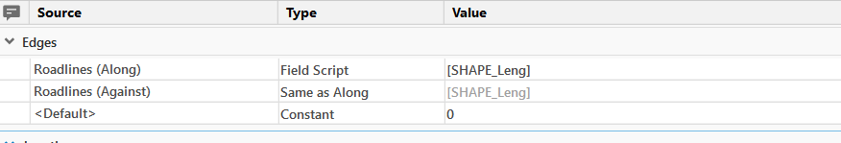

Under the Directions tab on the side, check the box for directions

Exit the box. Right Click the network dataset in the gdb again and click Build.

**Create Order/Depot points:**

Put required addresses in a CSV for geocoding

Geocode orders and depots CSVs using the Geocode Addresses tool.

Clean up geocoded locations by eliminating blank address rows (a problem on the depots version), and creating a name, start-time, and stop-time column for each. Eliminate unnecessary columns.

For each delivery set the start time to 8:00 AM and the end to 6:00 PM, except the two locations that should have 10:00 and 11:00 instead.

Figure 4: Example of start, end, and max violation times

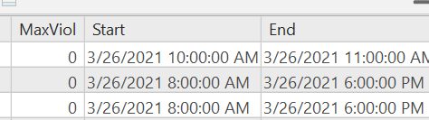

Feature sets are ready to pass into VRP layer

**Create Barrier Polygons:**

From a road centerlines layer, select all segments of both 35W and I94. Export these to a new layer.

Create 20-foot buffer around the new layer using the Buffer tool

Erase portions of the buffer using Split, that contain intersections to allow vehicles to cross the restricted roads.

Save this as a new layer

Figure 5: Overview of barrier polygons Figure 6: Example of cut-out intersection crossing

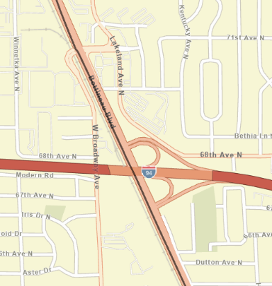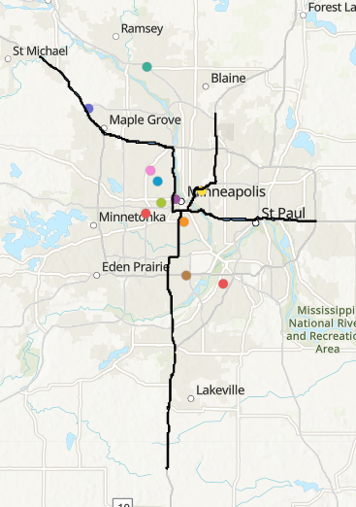

**Create the VRP Layer:**

Create a VRP layer from either ESRI or created network (change the source in the Analysis Tab, then the arrow under Network Analysis)

Add geocoded orders via Add Locations tool, and map name, start-stop fields. Set max violation time to 0. Make sure the Sublayer is set to Orders

Figure 7: Add locations and routes tools

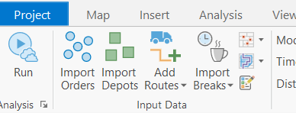

Add geocoded depots via Add Locations tool and map name, start-stop fields. Make sure the Sublayer is set to Depots

Add routes with the Add Vehicle Routing Problem Tool. Specify 2 routes, a start time of 8:00 AM, costs per unit time (it’s 1), and the max packages per truck

Add the polygon barrier layer via Add Locations. Map the required name field to the polygon’s ID. Make sure the Sublayer is set to Polygon Barrier

Click Run under the purple VRP tab.

Figure 8: Process Overview

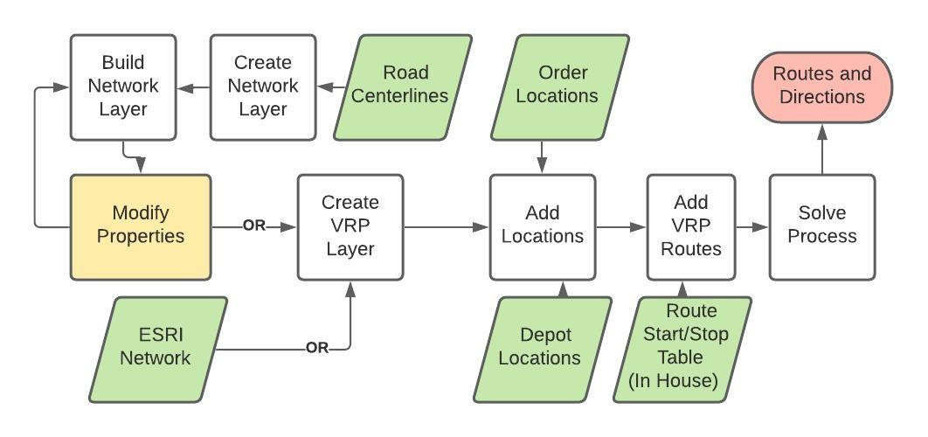

**Results**

The three network/barrier combination routes were created successfully, and show noticeable differences in route, mostly in regard to the ‘outer’ deliveries.

**Please see directions PDF after self-evaluation for directions!**

|  |  |  |
| --- | --- | --- |
| Created Network without Barriers | Created Network with Barriers | ESRI Network with Barriers |
|  |  |  |

**Results Verification**

There isn’t really a way to know if the route is truly the shortest, but it should be given the conditions (unless the conditions are not set correctly for the problem). Still, we can compare route times between datasets. We can also make sure the results get to deliveries on time, and avoid restricted interstates.

First Criteria: Hit all targets in required time frames

Second Criteria: Avoids restricted areas

Third Criteria: Finishes in under 3 hours

**Created wo Barriers:**

* First Criteria: All deliveries are made in appropriate time; time restricted deliveries are made at 9:24 (waits :34 until 10) and 10:05.
* Second Criteria: Does not avoid 35W and 94, but was not programmed to do so; valid
* Third Criteria: all routes finish by 10:24 AM, 2:24 from start time

**Created w Barriers:**

* First Criteria: All deliveries are made in appropriate time; time restricted deliveries are made at 9:34 (waits :26 until 10) and 10:05.
* Second Criteria: Successfully avoids 35W and 94.
* Third Criteria: all routes finish by 10:26 AM, 2:26 from start time

**ESRI w Barriers:**

* First Criteria: All deliveries are made in appropriate time; time restricted deliveries are made at 9:25 (waits :35 until 10) and 10:08. (The directions show the UTC times for limits for some reason)
* Second Criteria: Successfully avoids 35W and 94.
* Third Criteria: all routes finish by 10:39 AM, 2:39 from start time

**Discussion and Conclusion**

The primary goal in this lab was to compare created and pre-existing network datasets. The delivery times on the newly created dataset ended up being faster, but it is likely this is due to some improper network properties or non-current road data. The created network turned out better than expected. It is interesting to note that the second truck actually doesn’t help the time a lot. The last packages can’t be delivered until 10, which leaves enough time for one truck to get it all done. The second truck just means one of them has a wait time until 10. In theory, the shortest delivery time is 2 hours, from 8-10 AM, but cannot be faster due to time restrictions. All routes finish within 2-3 hours, but have large segments of just waiting on location. However, the number of packages per truck does affect the time: 5 vs 30 in the ESRI dataset causes a difference of about 11 minutes. The other two datasets were set to 30, and one of the versions only creates one route, which isn’t really fair to either of the drivers. This would certainly be worth playing with for each network dataset to find the optimal package limit.

The VRP solver is remarkably picky about the format of the data you send it. There were multiple problems where the dates weren’t manually set in the Default Date box in the VRP tab (instead of leaving as “today”, when “today” was the same date set elsewhere in the data). The barrier layer was a class-wide dilemma. By simply creating a barrier along all of 35 and 94, the computer interprets that it cannot cross the roads perpendicularly, which is possible when roads are closed. Therefore, all the little intersections with any street that cross the interstate had to be erased. This does affect the result; on another test layer I erased ALL intersections, and the time actually increased.

**References**

ESRI. (2020). Create a network dataset. Retrieved March 28, 2021, from <https://pro.arcgis.com/en/pro-app/latest/help/analysis/networks/how-to-create-a-usable-network-dataset.htm>

ESRI. (2020). Service a set of orders with a fleet of vehicles. Retrieved March 28, 2021, from <https://pro.arcgis.com/en/pro-app/latest/help/analysis/networks/service-a-set-of-orders-with-a-fleet-of-vehicles.htm>

**Self-score**

*Fill out this rubric for yourself and include it in your lab report. The same rubric will be used to generate a grade in proportion to the points assigned in the syllabus to the assignment.*

|  |  |  |  |
| --- | --- | --- | --- |
| **Category** | **Description** | **Points Possible** | **Score** |
| **Structural Elements** | All elements of a lab report are included **(2 points each)**:  Title, Notice: Dr. Bryan Runck, Author, Project Repository, Date, Abstract, Problem Statement, Input Data w/ tables, Methods w/ Data, Flow Diagrams, Results, Results Verification, Discussion and Conclusion, References in common format, Self-score | 28 | **27** |
| **Clarity of Content** | Each element above is executed at a professional level so that someone can understand the goal, data, methods, results, and their validity and implications in a 5 minute reading at a cursory-level, and in a 30 minute meeting at a deep level **(12 points)**. There is a clear connection from data to results to discussion and conclusion **(12 points)**. | 24 | **23** |
| **Reproducibility** | Results are completely reproducible by someone with basic GIS training. There is no ambiguity in data flow or rationale for data operations. Every step is documented and justified. | 28 | **26** |
| **Verification** | Results are correct in that they have been verified in comparison to some standard. The standard is clearly stated **(10 points)**, the method of comparison is clearly stated **(5 points)**, and the result of verification is clearly stated **(5 points)**. | 20 | **19** |
|  |  | 100 | **95** |